CV'26 App Specs

2- Shooting Target Score
Contents
Description 2
Main Idea 2
Rule 2
Minimum Requirements 2
Possible Add-ons (Bonuses) 3
SEEN Test Cases 3
Test Images for Minimum Requirements 3
Test Images for Bonuses 3
Requirements 3
Tech Eval: Hand-Crafted Approach 3
Methodology 3
Suggested Search Tracks and Keywords 3
References 3
Evaluation 4
Tech Eval: Data-Driven Approach 4
Methodology 4
Evaluation 4
Scenario Eval: GUI Application 4
Methodology 4
Evaluation 4
GUI 4
Required Buttons 4
Documentation 4

Description

Main Idea
A shooting sport is a competitive sport that involves testing accuracy and speed of contestants in aiming at targets. Shooting targets come in various forms and shapes and are used for firearm shooting practice (pistol, rifle, shotgun), as well as other non-firearm related sports (darts, target archery, crossbow).
The center of the target is often called the bullseye, which gives the highest points. Less points are given for hitting further ranges away from the center. Usually the referee, or the shooter, examines the target after a shooting session and calculates the score by summing the points associated with marks/holes on the target. This application aims to automate this process.
Assume the shooting target is round and consists of a board with several circles (ranges) stemming from the center (see figures below). The application should “examine” the target, detect the hits if any, and evaluate a final score depending on the locations of these hits.

Rule
- A bullseye hit (smallest circle): (100 × number of ranges) points.
- Each ranges hit is 50 points less than the previous range.
- If a hit spans two ranges, take the best-score range.
Input | 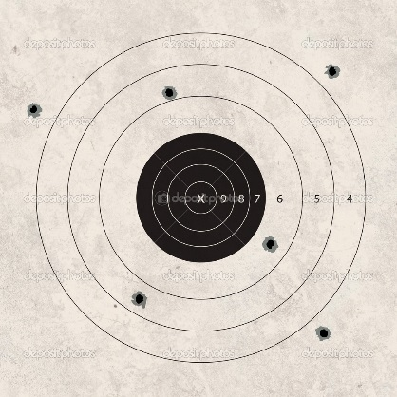 | 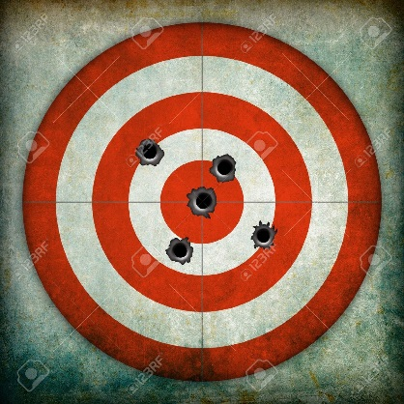 | 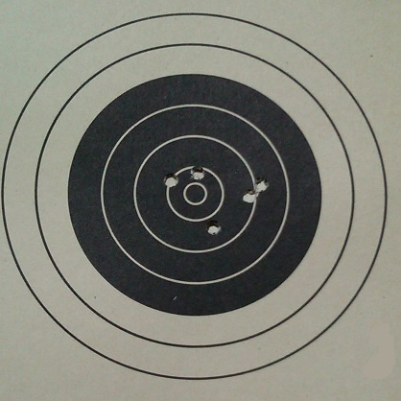
Output | Bullseye hit = 100×7=700  Total score = 1×500 + 2×450 + 3×0 = 1400 | Bullseye hit = 100×5=500  Total score = 2×500 + 3×450 = 2350 | Bullseye hit = 100×7=700  Total score = 2×650 + 2×600 + 1×550 = 3050

Minimum Requirements
Compute the score from a picture of a shooting target with:
- Frontal view with no background scene.
- Frontal view with background scene (possibly other objects).
- Different distances from the camera.
- Any color and any number or ranges.

Possible Add-ons (Bonuses)
Compute the score from a picture of a shooting target with:
- Varying illumination conditions and noise.
- Arbitrary perspectives (different camera angles).
- If a hit spans two ranges, take the range which contain max part of the shot.
- Different shapes (e.g. human board for gun target practice).

SEEN Test Cases

Test Images for Minimum Requirements
Case1: Frontal scene of a shooting target with no other objects.
Case2: Frontal scene of a shooting target with background scene.
Case3: Frontal scene of a shooting target with different colors and ranges.
Case4: Frontal scene of a shooting target with large number of holes.

Test Images for Bonuses
Case5: Frontal scene of a shooting target with dust or non-uniform illumination.
Case6: A scene of a shooting target from arbitrary perspectives.
Case7: Samples from previous cases with one or more hits span two ranges
Case8: Different target shapes.

Requirements

Tech Eval: Hand-Crafted Approach

Methodology
Solve the required problem using traditional image processing and analysis techniques

Suggested Search Tracks and Keywords
You may use some/all of the following keywords as a guide (not restricted to them):
- Segmentation
- Hough transform
- Morphological operations
- Region properties
- Color processing

References
- Textbook Ch. 3: Intensity Transformations and Spatial Processing
- Textbook Ch. 9: Morphological Image Processing
- Textbook Ch.10: Image Segmentation
- Textbook Ch. 11: Representation and Description

Evaluation
Results of testing on both SEEN & UNSEEN cases

Tech Eval: Data-Driven Approach

Methodology
- Select a dataset
- Apply one of the following methods:
  - Build a model from scratch
Results MUST be Enhanced
  - Transfer-learning an existing model
  - Fine-tune and existing model
- Train the model
- Test the model (before and after the fine-tune/transfer-learning)

Evaluation
Results of testing on both SEEN & UNSEEN cases

Scenario Eval: GUI Application

Methodology
- Acquire the image from Camera
- Apply the algorithm
- Output the result on GUI

Evaluation
Results of real-time testing one (or more) live cases

GUI

Required Buttons
- BROWSE a single image: apply the algorithm/model and display the output
- BROWSE ALL SEEN cases: apply the algorithm/model on each image & display its O/P
- ACQUIRE image from camera: apply the algorithm/model and display the output

Documentation
- Hand-Crafted: Briefly describe the steps & the used algorithms/methods
- Data-Driven: Briefly describe the used model & method
- Results:
  - Compare two approaches on SEEN Cases
  - Compare results before and after transfer-learn/fine-tune

